**CS590BD**

**Big Data Analytics and applications**

**LAB1 Assignment**

**Group:**

Tunuguntla,Jeevana

Bathina,Lakshmi Venkata Sandeep

Beeravalli,Ramakrishna Reddy

Marikanti,Goutham

**Task 1:Apps with Mobile devices ans sensors**

* + **Task1.1 :** T1 sensor Tag with android sensor app

**Steps**: a) Imported projected into workspace.

b)run the application as Android application.

c) following output produced.

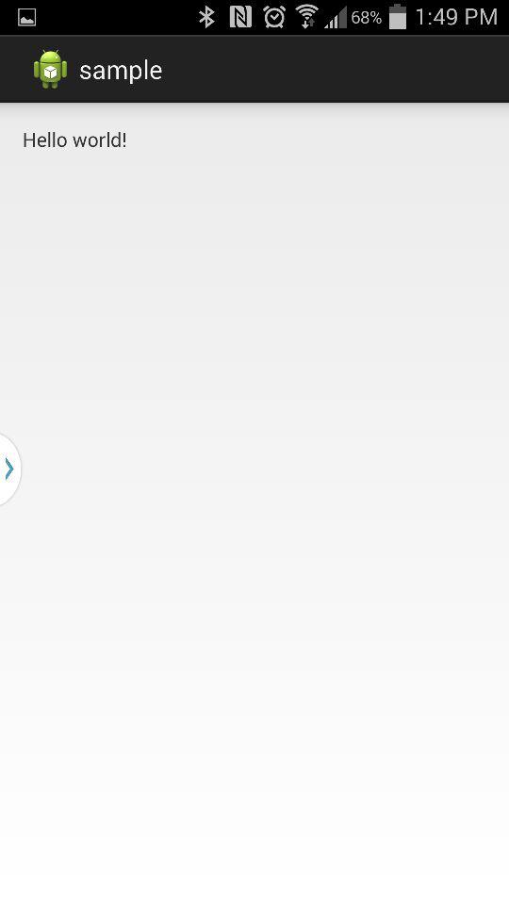

*Logcat view*

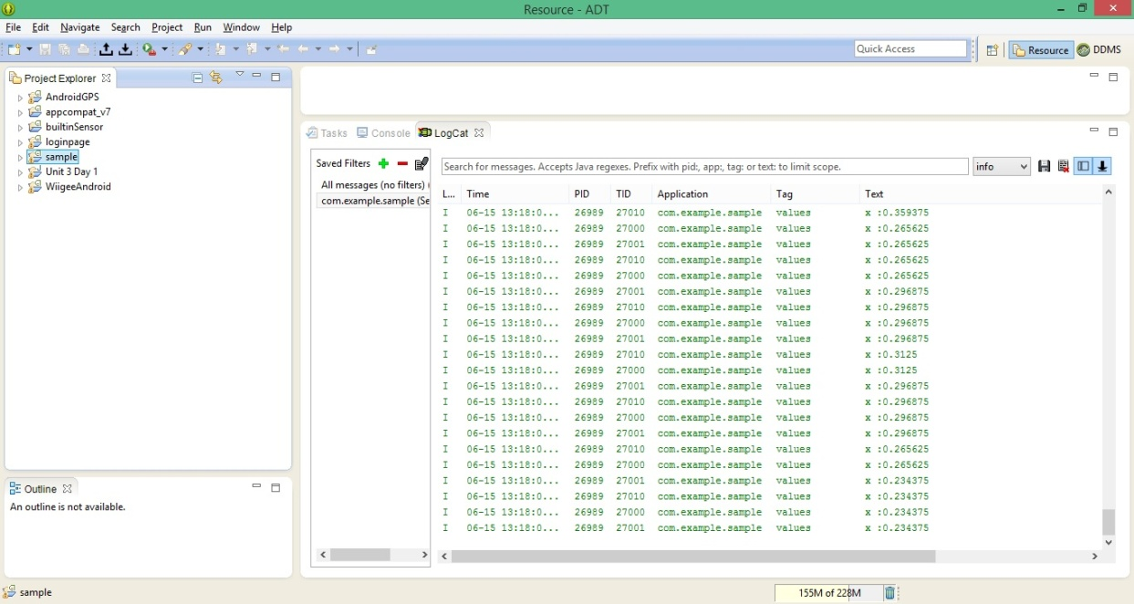

X coordinate value changes ,when you change the sensor location.

* **Task 1.2:** Mobile sensor with Android sensor app

**Steps:**a) run your application as android application.

b)following output will be produced

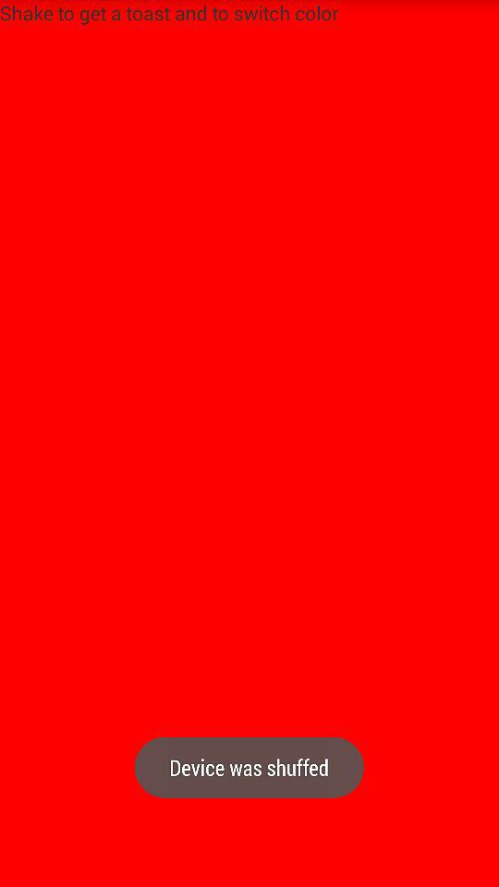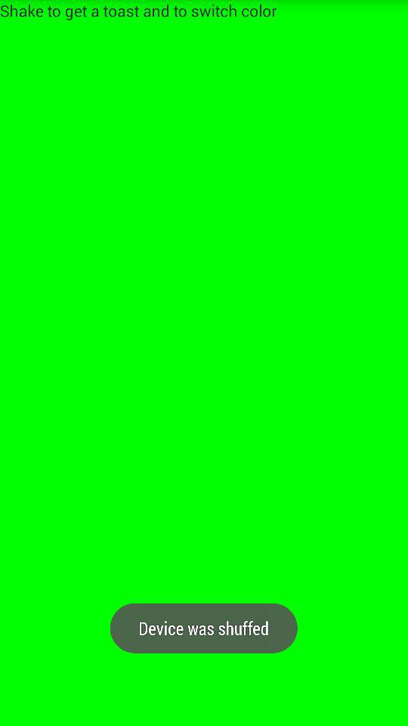

* **Task1.3:** GPS feature with Android smart phone

**Steps:** a) run your application as android application.

b)following output will be produced

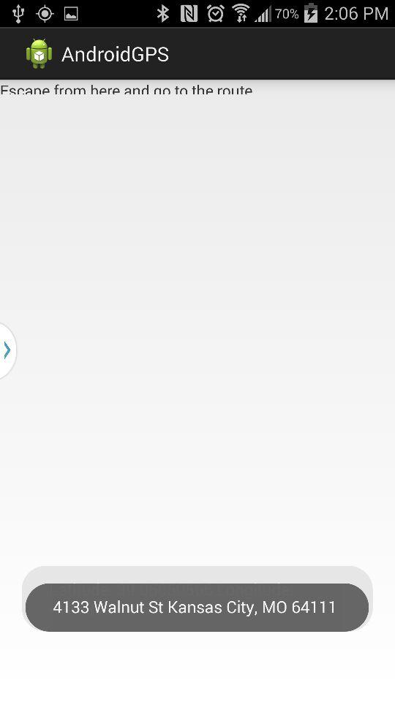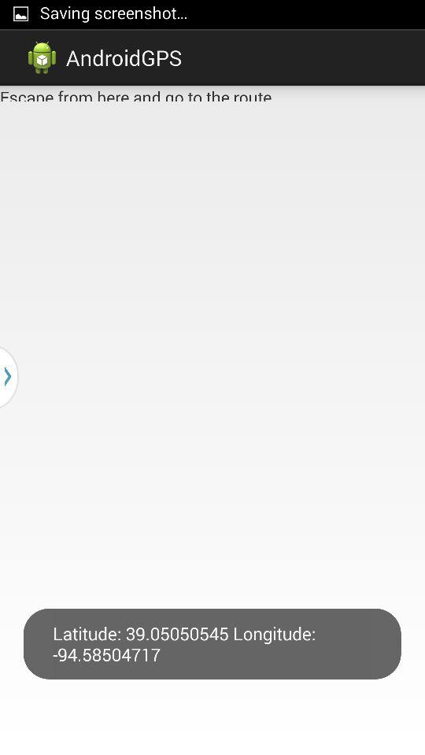

* **Task 1.4:** Wiigee app with Android smart phone.

**Steps:** a) run your application as android application.

b)following output will be produced

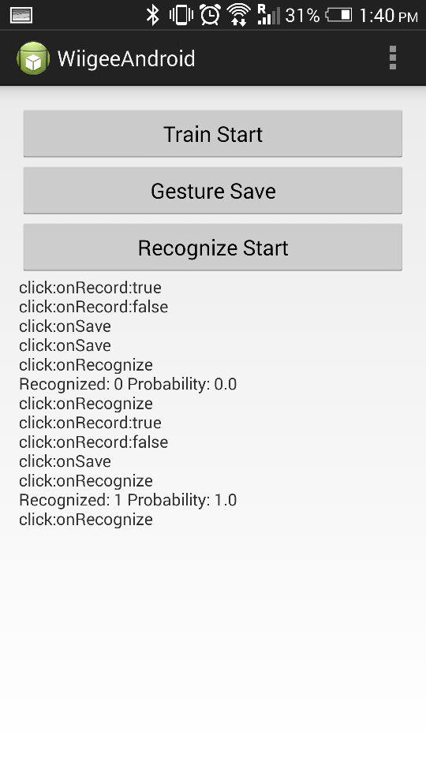

* **Task1.5:** T1 chronos watch with java app

**Steps:** a)Install the control center from CD,click start access point

b)following output will be produced

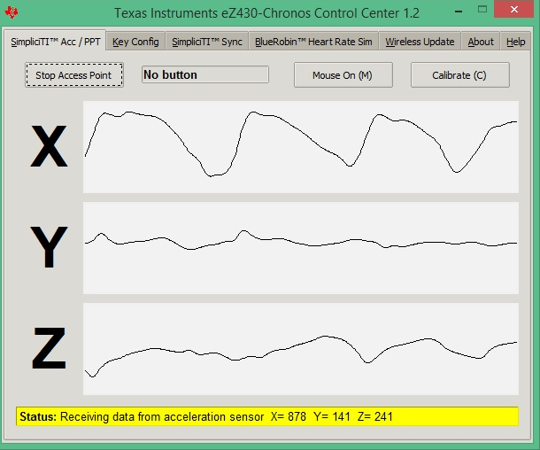

Demo for punchmeter game

